**Assignment 1**

As per the requirement i have completed the following, and snapshots for the same have been presented below.

1. Create a github account
2. Create a repository and create files
3. Install Git in your PC
4. Launch git bash and clone the remote repository to the local repository

**Creating a New Git hub repository**

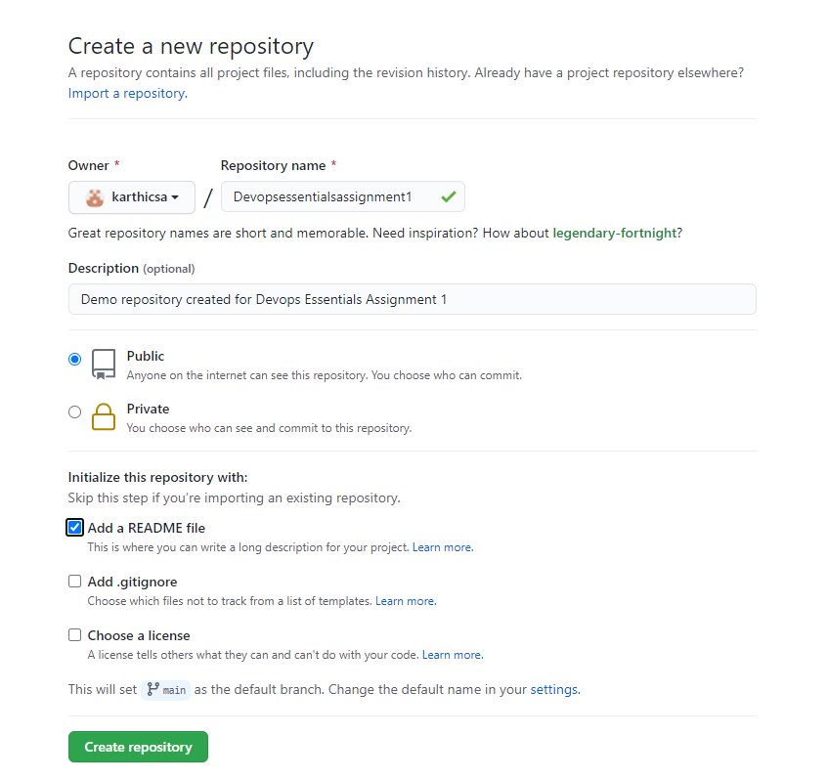

**Github repository post creating a new file**

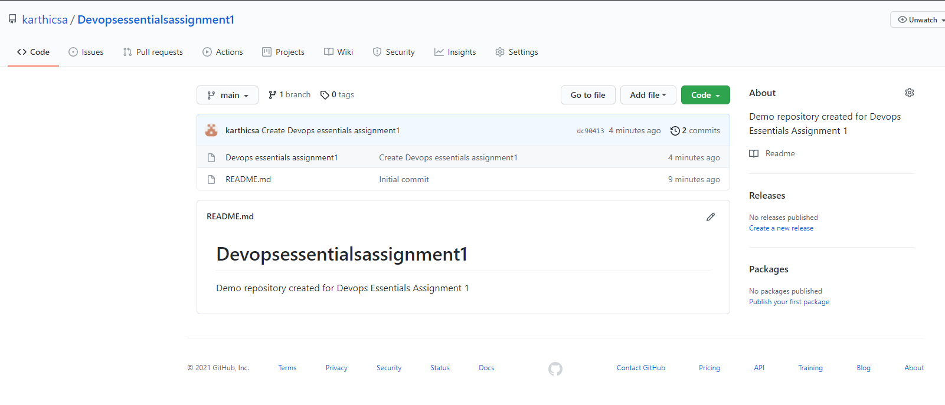

**Created new local folder for cloning the repository and using Git bash here after installing Github to local machine**

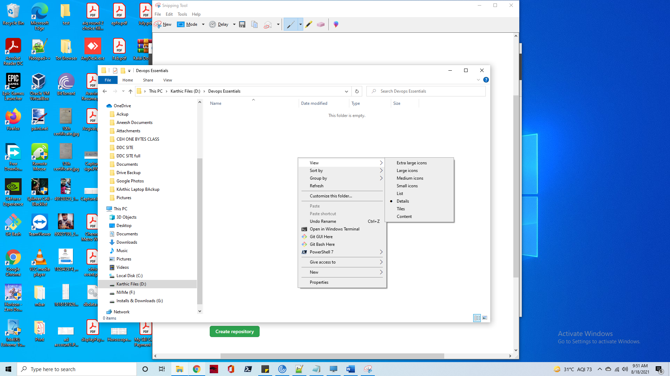

**Using git commands to initiate, set username and email globally and to clone the remote repository**

